PRACTICAL-1

AIM: Implementation of indexes, views.

THEORY:
INDEX
Indexes are special lookup tables that the database search engine can use to speed up data retrieval. Simply put, an index is a pointer to data in a table. When index is created on a column by default the value will be sorted in ascending order.

An index helps to speed up SELECT queries and WHERE clauses, but it slows down data input, with the UPDATE and the INSERT statements. Indexes can be created or dropped with no effect on the data.

SINGLE INDEX:
A single index is created based on only one table column.

Syntax:
CREATE INDEX index_name ON table_name(column_name);

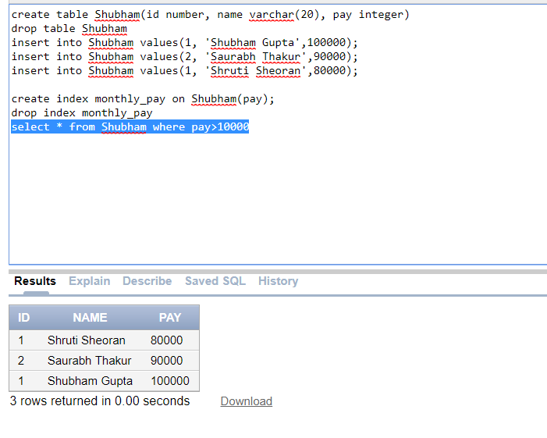
COMPOSITE INDEX:
A composite index is created based on more than one table column.

Syntax:
CREATE INDEX index_name ON table_name(column1_name, column2_name);

UNIQUE INDEX: Unique indexes are used not only for performance, but also for data integrity. A unique index does not allow any duplicate values to be inserted into the table. The basic syntax is as follows.

Syntax:
CREATE UNIQUE INDEX index_name ON table_name(column_name);

REVERSE INDEX: In reverse indexes data is sorted in descending order.
Syntax:
CREATE INDEX index_name ON table_name(column_name) REVERSE;

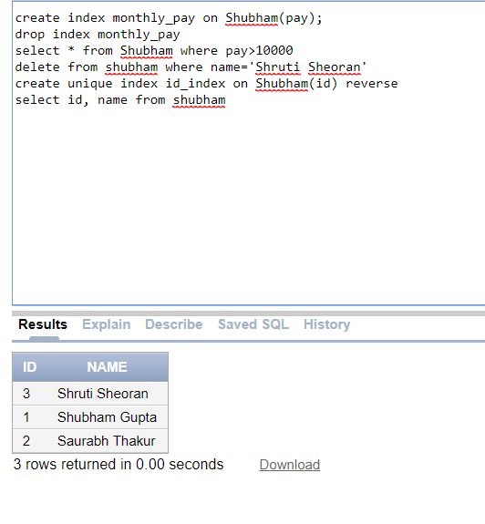

BIT-MAP INDEX: This index is created on those columns which have only two values Example: Gender, Marital Status etc.
Syntax:
CREATE BITMAP INDEX index_name ON table_name(column_name);
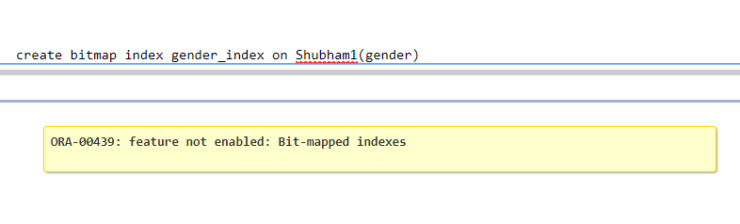

View
A view is nothing more than a SQL statement that is stored in the database with an associated name. A view is actually a composition of a table in the form of a predefined SQL query.

SINGLE VIEW:
A single view includes only one table column.
Syntax:
CREATE VIEW view_name AS SELECT column1
FROM table_name WHERE [condition];

COMPOSITE VIEW:
A composite view includes more than one table column.
Syntax:
CREATE VIEW view_name AS SELECT column1, column2 ….
FROM table_name WHERE [condition];

COMPLETE VIEW:
A complete view includes every column of the table.
Syntax:
CREATE VIEW view_name AS SELECT *
FROM table_name WHERE [condition];

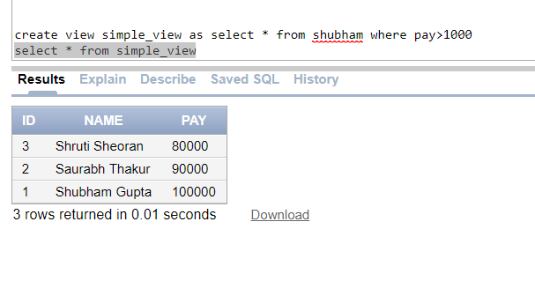

FORCED VIEW:
A forced view is created before the creation of the table. As soon as table is created the view will perform its normal functionality.
Syntax:
CREATE FORCE VIEW view_name AS SELECT column1, column2, …
FROM table_name WHERE [condition];

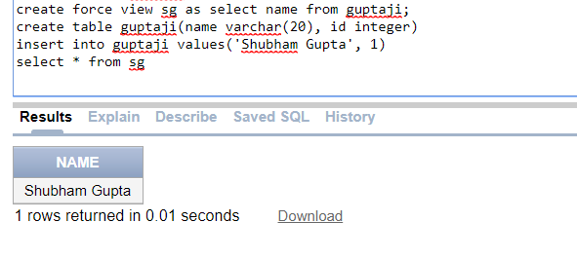

MATERIALIZED VIEW
Materialized views are stored on disk and are updated periodically based upon the query definition.
Syntax:
CREATE MATERIALIZED VIEW view_name AS SELECT column1, column2, …
FROM table_name WHERE [condition];

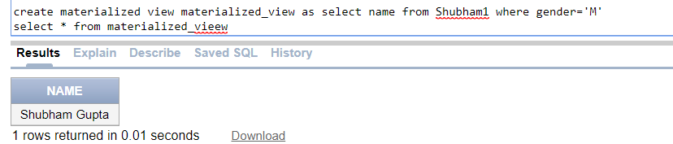

PRACTICAL-2

AIM: Implementation of sequences, clusters.

THEORY:
SEQUENCE
Sequence is a set of integers 1, 2, 3, … that are generated to produce unique values on demand.

Sequences are frequently used in databases because many applications require each row in a table to contain a unique value and sequences provides an easy way to generate them.

The sequence of numeric values is generated in an ascending or descending order at defined intervals and can be configured to restart when exceeds max_value

Syntax:
CREATE SEQUENCE sequence_name
START WITH initial_value
INCREMENT BY increment_value
MINVALE minimum value
MAXVALUE maximum value
CYCLE | NOCYCLE;
INSERT INTO table_name(sequence_name.NEXTVAL);

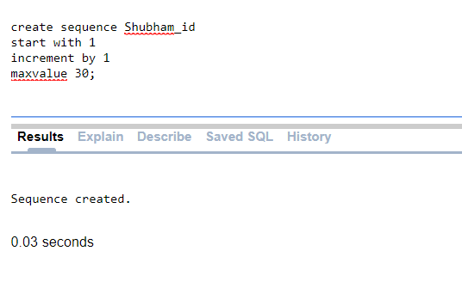

CLUSTER
A cluster is a schema object that contains data from one or more tables, all of which have one or more columns in common. A cluster ties data values to disk location.
A cluster key is used to group data together. All rows of all tables with the same value of the cluster key are stored in the same data block.

Syntax:
CREATE CLUSTER cluster_name(column_name datatype);
CREATE INDEX index_name ON CLUSTER cluster_name;
CREATE TABLE table_name(column_name datatype, …)
CLUSTER cluster_name(column_name);

To see list of cluster:
SELECT * FROM USER_CLUSTERS;

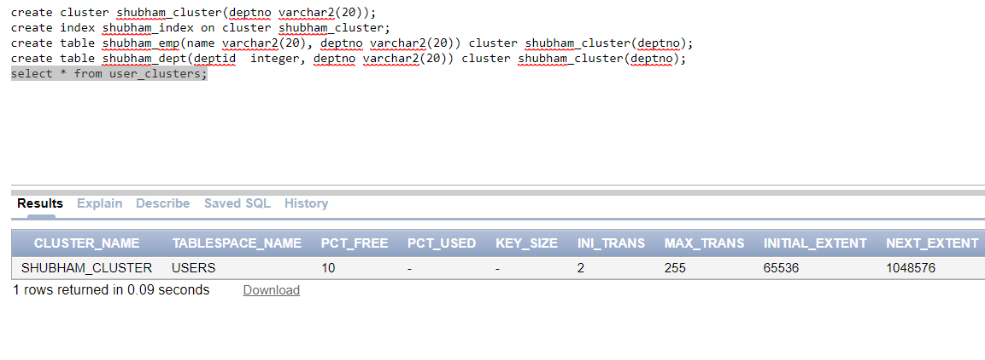

PRACTICAL-3

AIM: Introduction to PL/SQL Concepts, its features and shows how PL/SQL meets the challenges of database programming, and how you can reuse techniques that you know from other programming languages

THEORY:
PL/SQL
PL/SQL is a combination of SQL along with the procedural features of programming languages. It was developed by Oracle Corporation in the early 90's to enhance the capabilities of SQL. PL/SQL is one of three key programming languages embedded in the Oracle Database, along with SQL itself and Java.
PL/SQL is a block structured language. The programs of PL/SQL are logical blocks that can contain any number of nested sub-blocks. Pl/SQL stands for "Procedural Language extension of SQL" that is used in Oracle.

BLOCK STRUCTURE:
- DECLARE
- BEGIN
- EXCEPTION
- END
BEGIN and END are mandatory blocks other two are optional.

PL/SQL has the following features −
- PL/SQL is tightly integrated with SQL.
- It offers extensive error checking.
- It offers numerous data types.
- It offers a variety of programming structures.
- It supports structured programming through functions and procedures.
- It supports object-oriented programming.
- It supports the development of web applications and server pages.

PL/SQL meets the challenges of database programming −
- SQL is the standard database language and PL/SQL is strongly integrated with SQL. PL/SQL supports both static and dynamic SQL. Static SQL supports DML operations and transaction control from PL/SQL block. In Dynamic SQL, SQL allows embedding DDL statements in PL/SQL blocks.
- PL/SQL allows sending an entire block of statements to the database at one time. This reduces network traffic and provides high performance for the applications.
- PL/SQL gives high productivity to programmers as it can query, transform, and update data in a database.
- PL/SQL saves time on design and debugging by strong features, such as exception handling, encapsulation, data hiding, and object-oriented data types.
- Applications written in PL/SQL are fully portable.
- PL/SQL provides high security level.
- PL/SQL provides access to predefined SQL packages.
PL/SQL reuses techniques used by other programming languages −
- PL/SQL provides access to predefined SQL packages.
- PL/SQL provides support for Object-Oriented Programming.
- PL/SQL provides support for developing Web Applications and Server Pages.

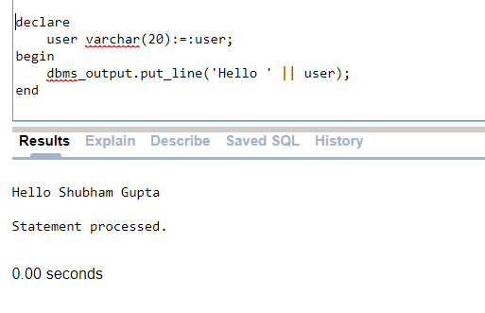

PRACTICAL-4

AIM: How to structure the flow of control through a PL/SQL program. Connect the statements by simple but powerful control structures that have a single entry and exit point. Collectively, these structures can handle any situation. Their proper use should leads naturally to a well-structured program.

THEORY:
FLOW CONTROL

IF-THEN-ELSE statement

IF statement adds the keyword ELSE followed by an alternative sequence of statement. If the condition is false or NULL, then only the alternative sequence of statements get executed. It ensures that either of the sequence of statements is executed.

IF-THEN-ELSIF statement

It allows you to choose between several alternatives.

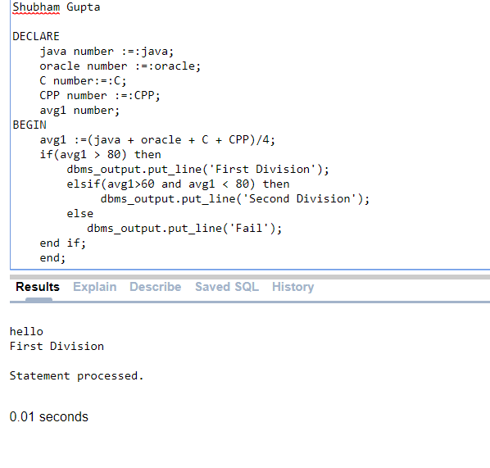
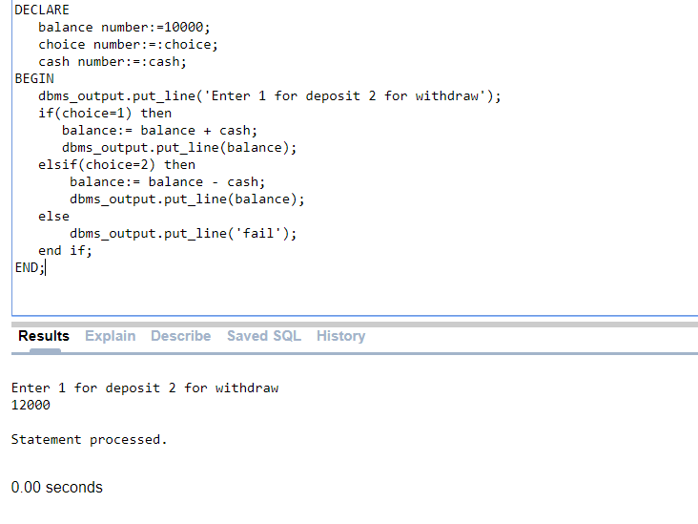

CASE statement
Like the IF statement, the CASE statement selects one sequence of statements to execute.
However, to select the sequence, the CASE statement uses a selector rather than multiple Boolean expressions. A selector is an expression whose value is used to select one of several alternatives.
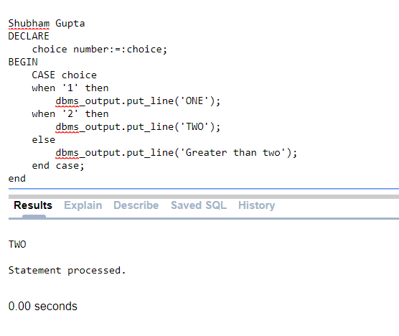

PL/SQL WHILE LOOP
Repeats a statement or group of statements while a given condition is true. It tests the condition before executing the loop body.
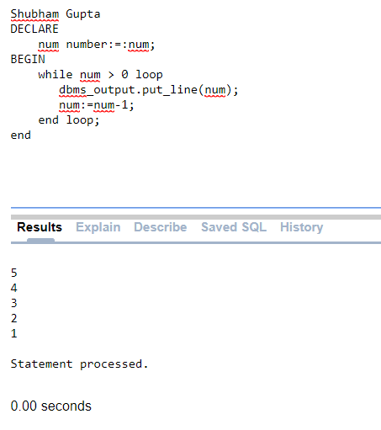
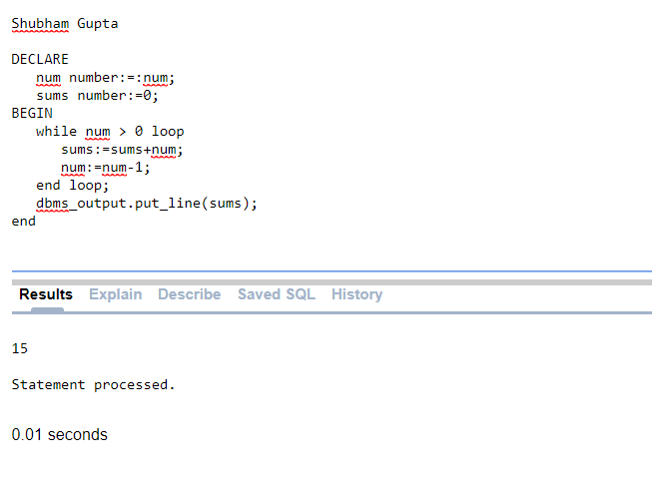

PL/SQL FOR LOOP
Execute a sequence of statements multiple times and abbreviates the code that manages the loop variable.

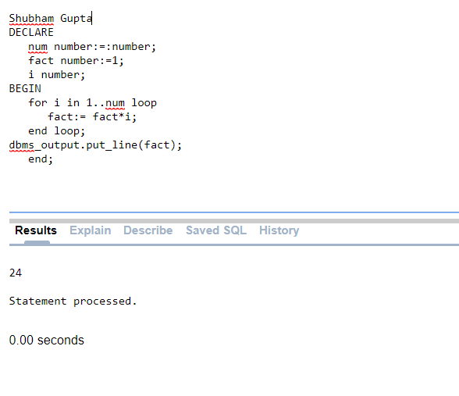
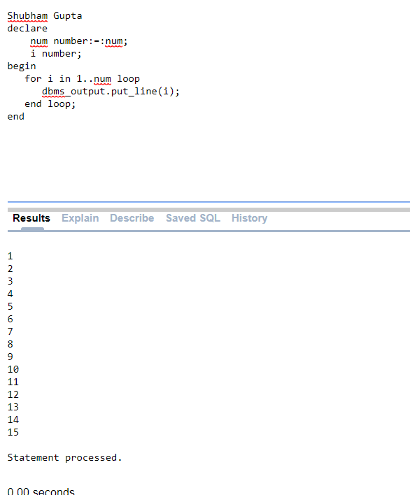

PRACTICAL-5,6

AIM: The Run-time errors arise from design faults, coding mistakes, hardware failures, and many other sources. Although you cannot anticipate all possible errors, you can plan to handle certain kinds of errors meaningful to your PL/SQL program. With PL/SQL mechanism called exception handling design "bulletproof” program so that it can continue operating in the presence of errors.

THEORY:
Exceptions

PL/SQL supports programmers to catch such conditions using EXCEPTION block in the program and an appropriate action is taken against the error condition. There are two types of exceptions −
- System-defined exceptions
- User-defined exceptions
The general syntax for exception handling is as follows:
DECLARE
<declarations section>
BEGIN
<executable command(s)>
EXCEPTION
<exception handling goes here >
WHEN exception1 THEN
exception1-handling-statements
........
WHEN others THEN
exception3-handling-statements
END;

System-defined Exceptions
The system exception is raised by PL/SQL run-time when it detects an error. For example, NO_DATA_FOUND exception is raised if you select a non-existing record from the database.
Some pre-defined exceptions:
- CASE_NOT_FOUND
SQL CODE: -6592
It is raised when none of the choices in the WHEN clause of a CASE statement is selected, and there is no ELSE clause.
- DO_NOT_FOUND
SQLCODE: -100
It is raised when a SELECT INTO statement returns no rows.
- INVALID_CURSOR
SQLCODE: -1001
It is raised when attempts are made to make a cursor operation that is not allowed, such as closing an unopened cursor.
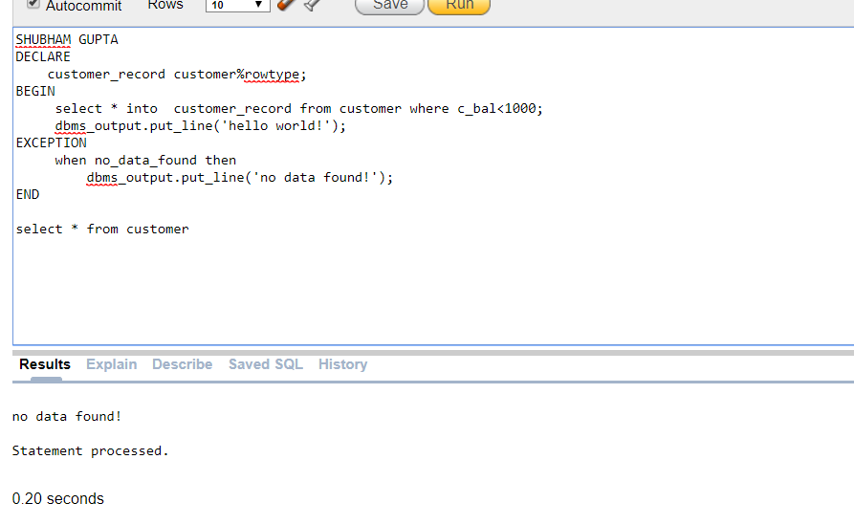

PRACTICAL-7

AIM: PL/SQL give you control to make your own exception base on oracle rules. User define exception must be declare yourself and RAISE statement to raise explicitly. Use PL/SQL user defined exception to make your own exception.

THEORY:
User-defined Exceptions
The user-defined exception is defined by user in a specific application. User can map exception names with specific Oracle errors using the EXCEPTION_INIT pragma.
Exceptions are raised by the database server automatically whenever there is any internal database error, but exceptions can be raised explicitly by the programmer by using the command RAISE.
SYNTAX:
DECLARE
exception_name EXCEPTION;
BEGIN
IF condition THEN
RAISE exception_name;
END IF;
EXCEPTION
WHEN exception_name THEN
statement;
END;
EXCEPTION_INIT pragma.
Pragma is a keyword directive to execute proceed at compile time. pragma EXCEPTION_INIT function take this two argument,
exception_name
error_number
You can define pragrma EXCEPTION_INIT in DECLARE BLOCK on your program.
PRAGMA EXCEPTION_INIT(exception_name, -error_number);
exception_name is character string up to 2048 bytes support and error_number is a negative integer range from -20000 to -20999.
SYNTAX:
DECLARE
user_define_exception_name EXCEPTION;
PRAGMA EXCEPTION_INIT(user_define_exception_name, -error_number);
BEGIN
statement(s);
IF condition THEN
RAISE user_define_exception_name;
END IF;
EXCEPTION
WHEN user_define_exception_name THEN
END;
